Prerequisites | Manual Handling Documents
Objectives | - To Prepare and Change Reels  - To Operate and Change Over Both BVM Wrappers on RM7  - To Print and Refeed Label Feeders  - To Operate The Pallet Over Wrapper
Risk Assessments | - EX01 – (Manual Handling Reel End and Wrapper Line)  - EX02 – (Operating Over Wrapper)  - EX03 – (Operating Reel End)  - EX04 – (Operating Entire BVM Wrapper Line)  - GEN01 – (Operating Electric Pallet Truck)  - KU3 – (BVM Wrapper and Tunnel)
Quality Procedures | - QSD476 – Exercise Book Machine  - QSD476B – Production Checklist  - QSD710 – Storage and Handling Instructions  - QSD7102 – Production Procedure  - QSD7103 – Printed Cover Organisation Procedure  - QSD7501 – Gold Standard Procedure

Standard PPE Requirements For Department

Steel toe cap footwear is required for the department operation, whether these be in the form of boots or shoes, both are acceptable. Please contact your departmental manager immediately if you do not have the correct footwear. | 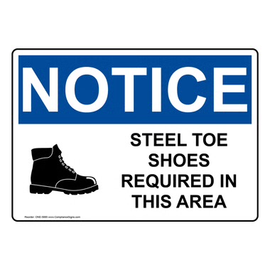
Ear protection is provided at the entrance to the department and is a requirement during production activity times. Please contact your departmental manager immediately if you require alternative hearing protection. | 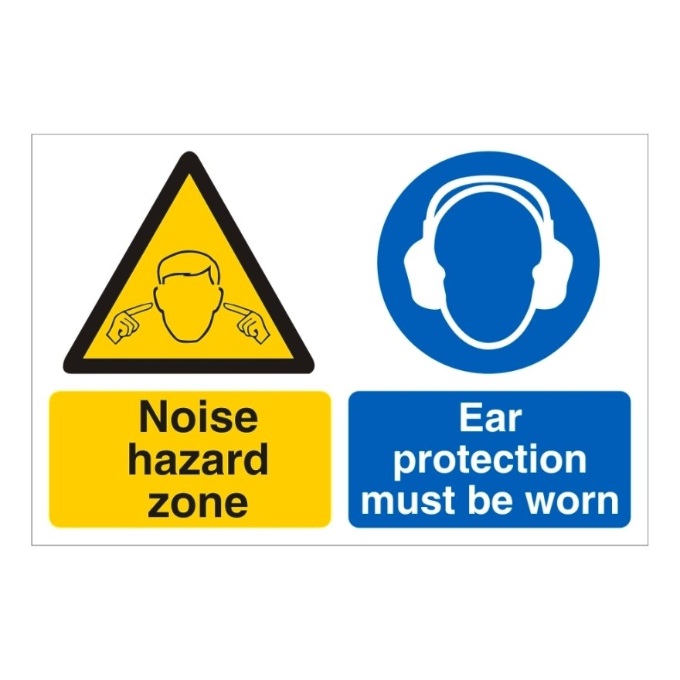

Machine Operation Health and Safety

In the event of an emergency, use one of the following processes to stop the machine.  - Emergency Stop  - Interlocked Guards  - Mains Isolator | 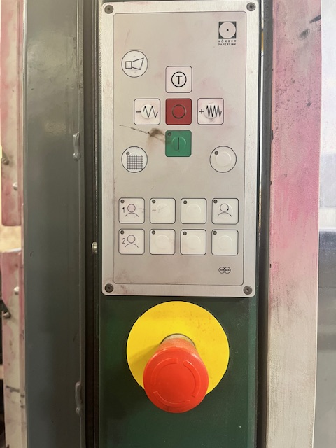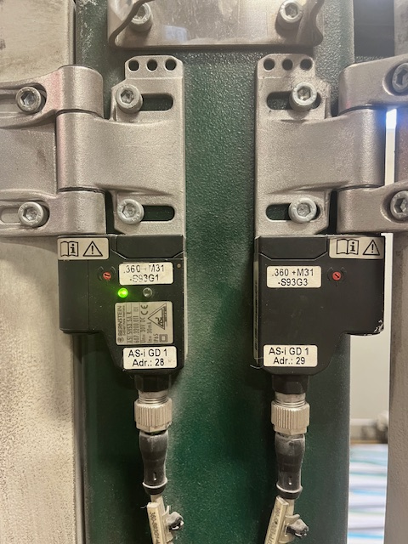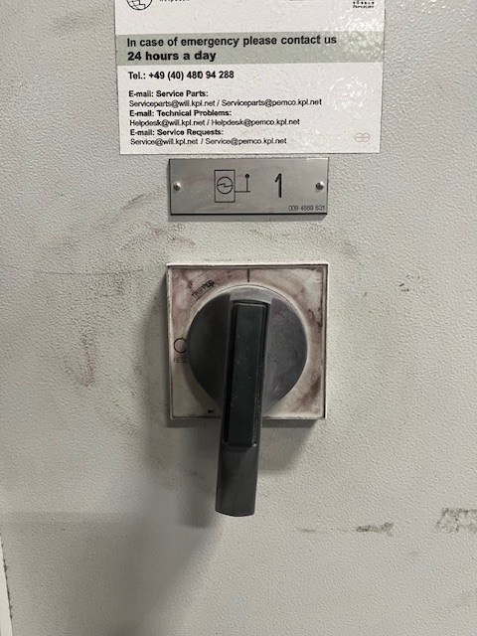
In the event of an emergency, use one of the following to stop the BVM Wrappers.  - Emergency Stop  - Interlocked Guards  - Mains Isolator | 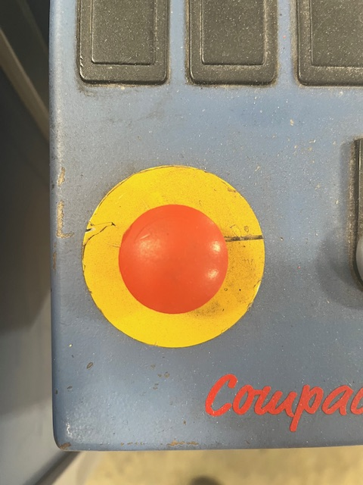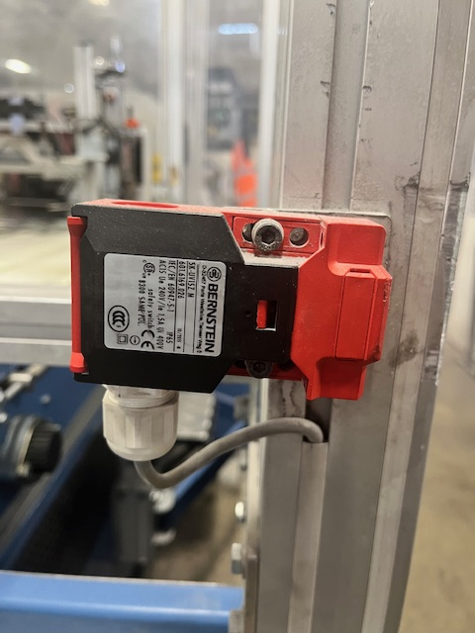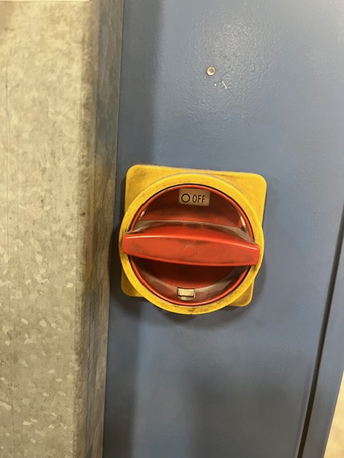
In the event of an emergency, use one of the following to stop the Shrink Tunnel.  - Emergency Stop  - Mains Isolator | 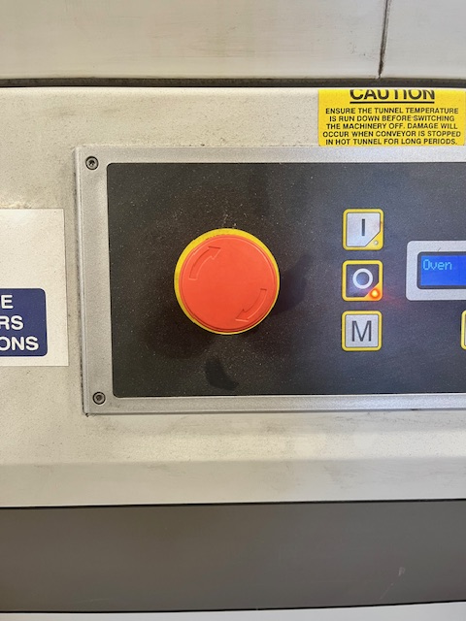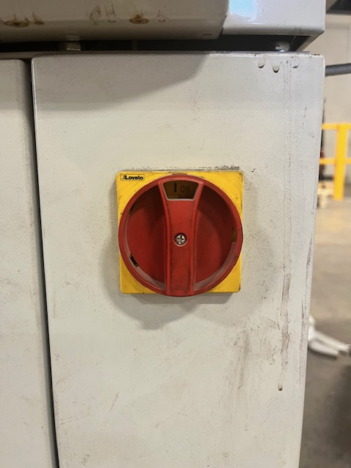

Prepare Reels

What PPE is required? | - Steel toe cap footwear  - Hearing Protection
Risk Assessment Ref. | - EX01  - EX03  - EX17  - GEN01
Quality Procedure Ref. | - QSD476  - QSD710  - QSD7102

Pre-Shift Check | Make sure the correct equipment is available to ensure a safe operation. Ensure not to overfill the work area and use a powered reel truck to prevent any strains. Check for hazards and report to the nearest operator/manager before commencing operation.

1. Check to ensure you are equipped for the reel preparation requirements e.g. snail, knife | 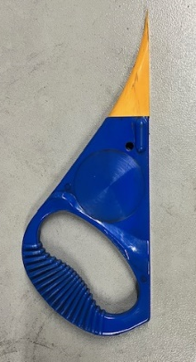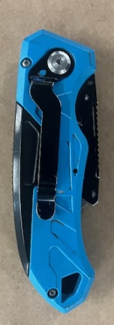
2. Check for the correct reel requirements and identify which reel is required. This can be found on the reel label | 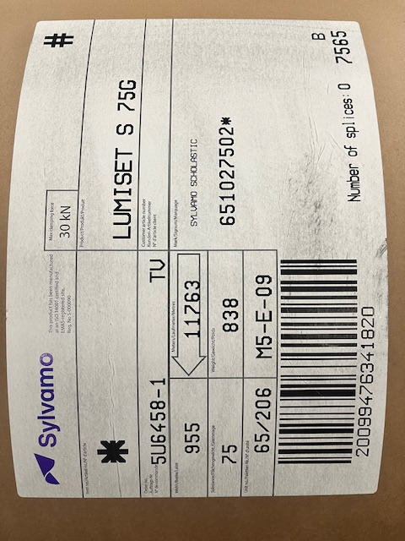
3. Remove all reel wrapping and check for reel damage, dispose of any bungs. Report any damage to the machine operator/manager | 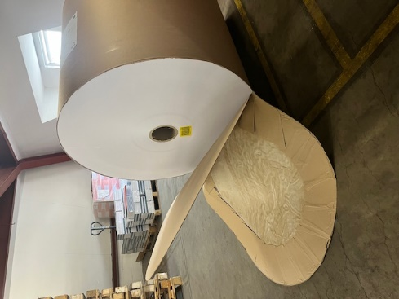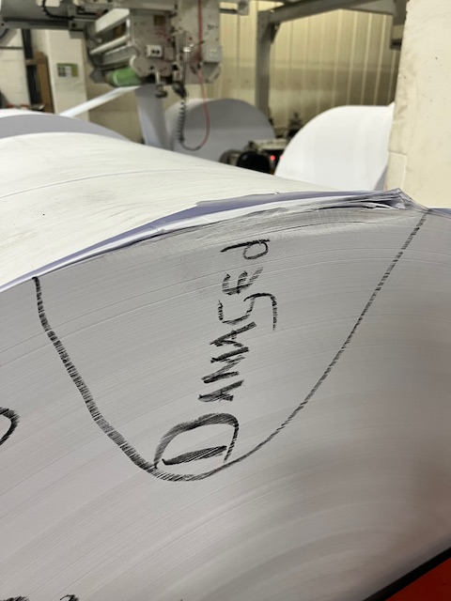  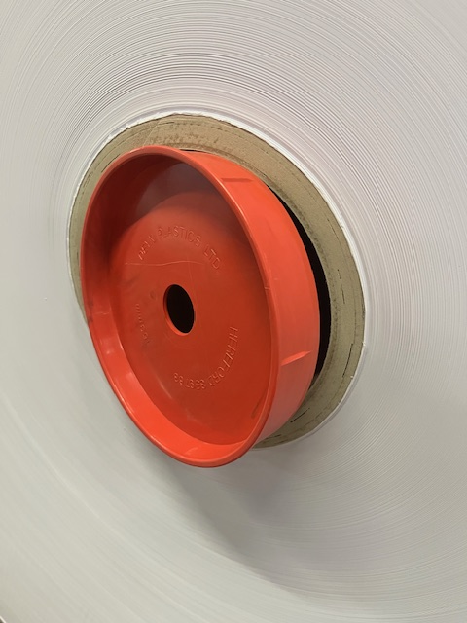
4. When running 2/4 reels, measure and match up reel sizes so that waste is kept to a minimum *Careful not to overfill the work area* | 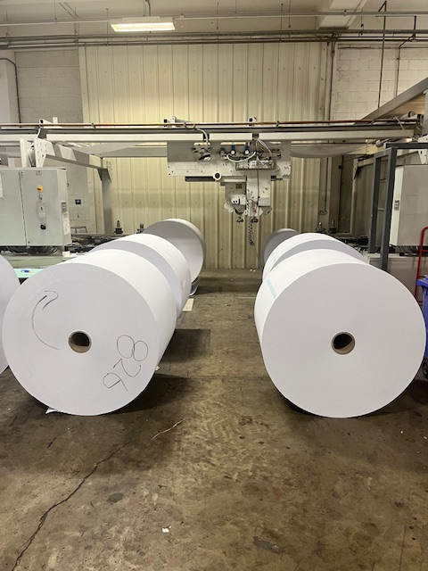
5. Place all reel wrapping in the correct waste location | 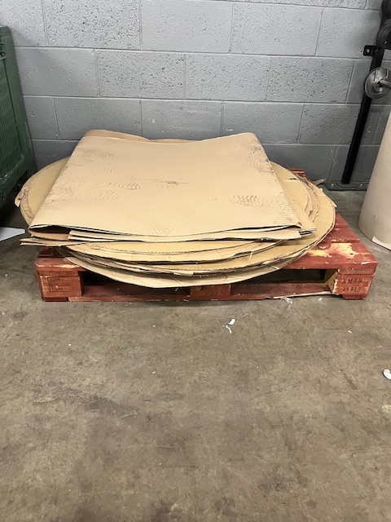
6. Position the reels onto the yellow floor skates with the use of the electric pallet truck | 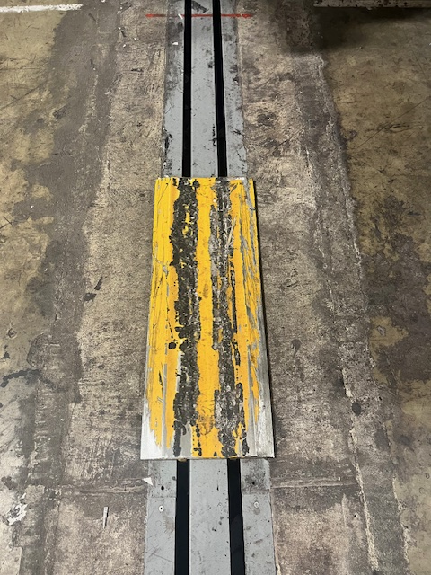

Change Reels

What PPE is required? | - Steel toe cap footwear  - Hearing Protection
Risk Assessment Ref. | - EX01  - EX03  - EX17  - GEN01
Quality Procedure Ref. | - QSD476  - QSD710  - QSD7102

Pre-Shift Check | This section cannot be signed off fully until the trainee has had experience with operating a twin web and reels that run through the machine at a higher speed. Ensure hands are clear at all times when springs are compressing.

1. When the horn sounds, the machine will automatically stop before the reel runs off
2. Remove the waste reel core or part reel from the machine

3. Press the up arrow to lift the arms to the top position | 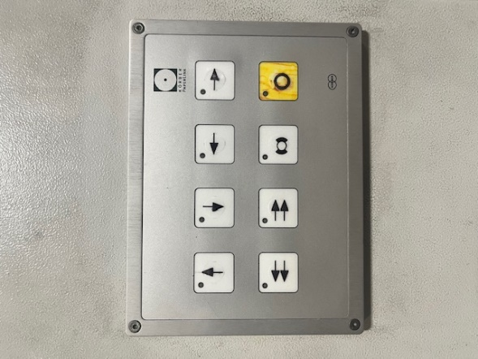
4. Slide a new reel on the yellow skates into the reel stand and line it up between the rams | 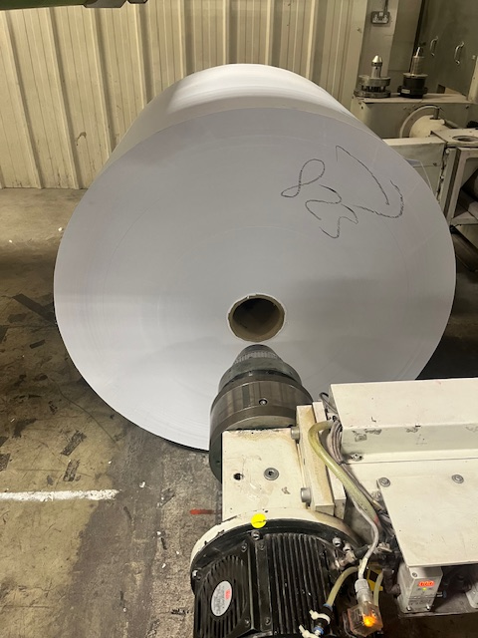
5. Press the down arrow to line the rams up with the reel cores. Manually push the reel onto the far arm | 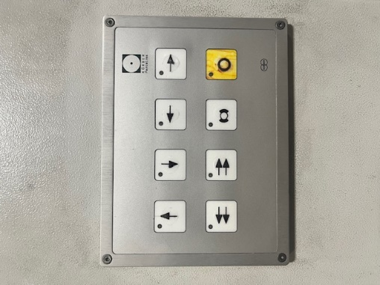
6. Press the right arrow until the springs compress *Keep hands clear of the springs* | 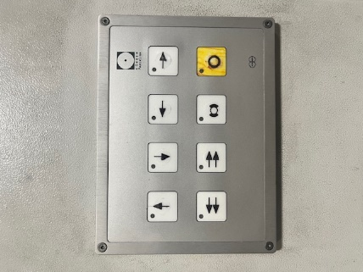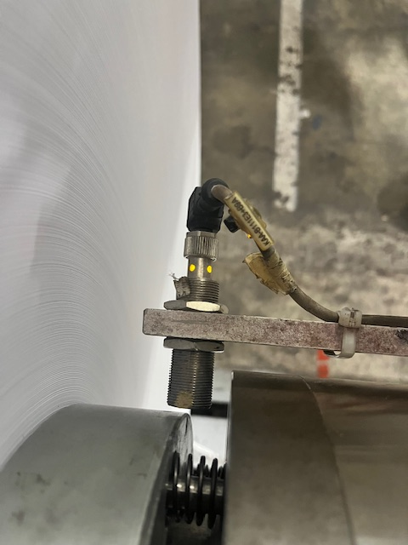
7. Press the up arrow to lift the reel slightly off the floor. Make sure to put air into the core chucks and the light is on the monitoring sensor. *ENSURE TO USE THE REEL AND NOT THE CHUCK TO ROTATE WHEN FINDING THE AIR CONNECTION* | 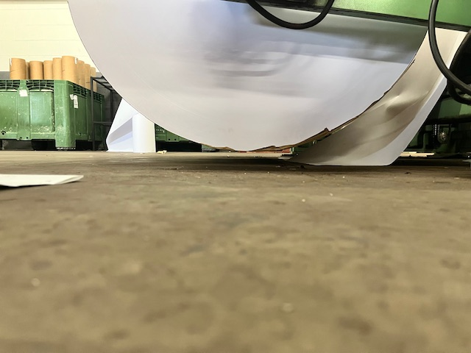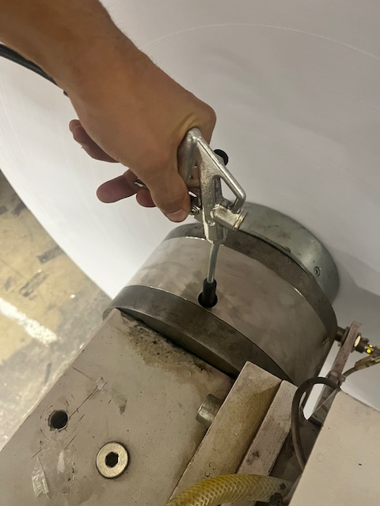
8. Only strip off three layers/wraps of paper from the reel, unless the reel has any visible damage. Remember to report all damage to the machine operator/manager

9. Press the right arrow and the black button on the other unit together | 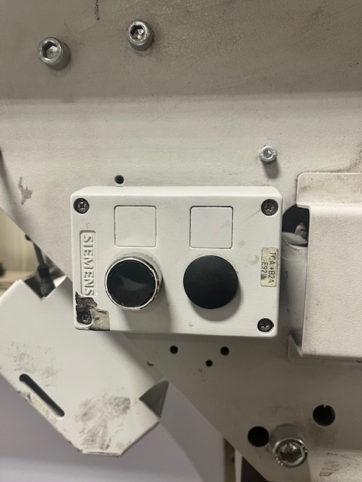

Making a Splice

What PPE is required? | - Steel toe cap footwear  - Hearing Protection
Risk Assessment Ref. | - EX01  - EX03  - EX17  - GEN01
Quality Procedure Ref. | - QSD476  - QSD710  - QSD7102

Pre-Shift Check | This section cannot be signed off fully until the trainee has had experience with operating a twin web and reels that run through the machine at a higher speed.

1. Turn the air on to hold the paper in place. Thread the paper through the separating bar on the right hand side units only | 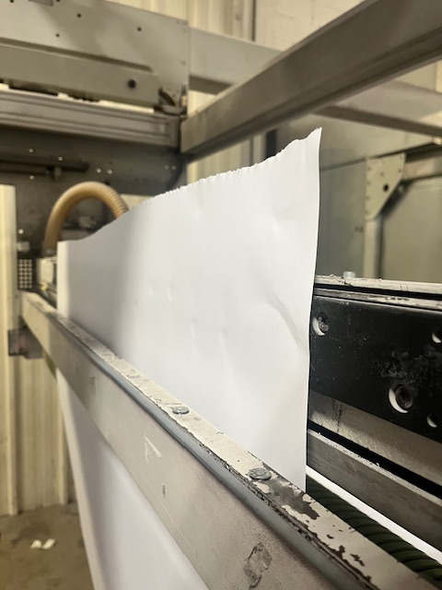
2. Line the paper up so it is parallel with the reel on the suction pads. Wind up the slack on the reel. Place the knife in the top slit and cut off
3. Use tape to the correct width required, trim off any edges to taper the reel. Remember to remove the double sided tape before the next section | 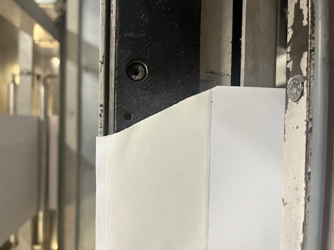
4. Turn the brake back on (When the light is not on, the brake is not off!)
5. Press the right arrow and the black button on the other unit together. After a short delay the units will come together. Make the splice | 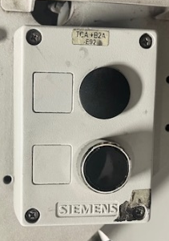  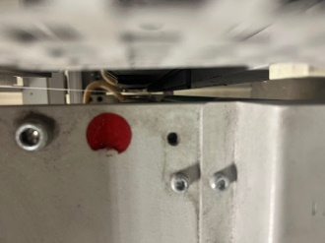

Replace Wire Drum

What PPE is required? | - Steel toe cap footwear  - Hearing Protection
Risk Assessment Ref.
Quality Procedure Ref. | - QSD476  - QSD710  - QSD7102

Pre-Shift Check | A demonstration must be shown before training can commence. Ensure the crane is safe to use and that manual handling procedures are adhered to. Pallet rucks and trollies are available to use

1. Lower the crane and attach the bar to each strap on the wire drum
2. Lift the wire drum up to the required height and roll the trolley underneath the drum. Lower the drum and detach the crane
3. Move the drum into the correct position and feed the new wire through the pipe to the stitching head

Change Reel on BVM Wrapper/Operate the Crane

What PPE is required? | - Steel toe cap footwear  - Hearing Protection
Risk Assessment Ref. | - EX01  - EX04  - KU3
Quality Procedure Ref. | - QSD476  - QSD710  - QSD7102

Pre-Shift Check | This operation requires three members of staff to complete successfully,  No.1 Pile down before wrapper so the machine continues to operate  No.2 Remove old wrap and replace with new, proceed to thread  No.3 Pull the new wrap through and inch waste onto wheel  The procedure should take a maximum of 8 minutes from stopping the wrapper to a running state.

1. Manually carry a plastic reel underneath the lifting crane, use another member of staff to assist
2. Lower the hook using the hands device until 2 foot from the floor. Thread the bar through the reel core
3. Secure two straps on either side of the bar and attached to the crane hook. Using the hand device, lift the reel up to the correct wrapper height
4. Walk the reel to the wrapper and lower onto the reel rollers. Disconnect the straps and bar from the hook and reel, then return the hook to the highest position and store the bar and straps out of the way safely

Refeeding the Labeller

What PPE is required? | - Steel toe cap footwear  - Hearing Protection
Risk Assessment Ref. | - EX01  - EX04  - KU3
Quality Procedure Ref. | - QSD476  - QSD710  - QSD7102

Pre-Shift Check | When a reel needs changing during production periods, another member must be able to carry on piling down whilst the label reel change is being executed. Ensure you have the correct reel stock before changing and that the data is correct and unified on the new label.

1. Pause the labeller by the lower control panel. Lift the lid on the labeller and remove the waste labels and reel end waste | II
2. Release the reel side guide and insert a new reel. Thread the labels through as per the diagram | 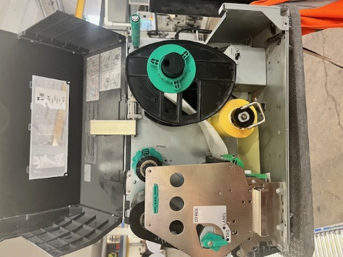
3. Do a final quality check to ensure the labels are straight and correctly printed. Replace the drive roller and restart the machine using the Restart button | 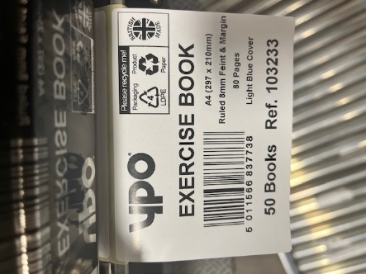

Pile Down

What PPE is required? | - Steel toe cap footwear  - Hearing Protection
Risk Assessment Ref. | - GEN01
Quality Procedure Ref. | - QSD476  - QSD710  - QSD7102

Pre-Shift Check | Keep the packing area clear and tidy. Make sure you have the correct amount of empty pallets needed and that the labeller is set up for the current job. The pallet lifter will need to be fully charged as well as the electric pallet truck.

1. Follow the pallet formation and instruction plan for each specific order | 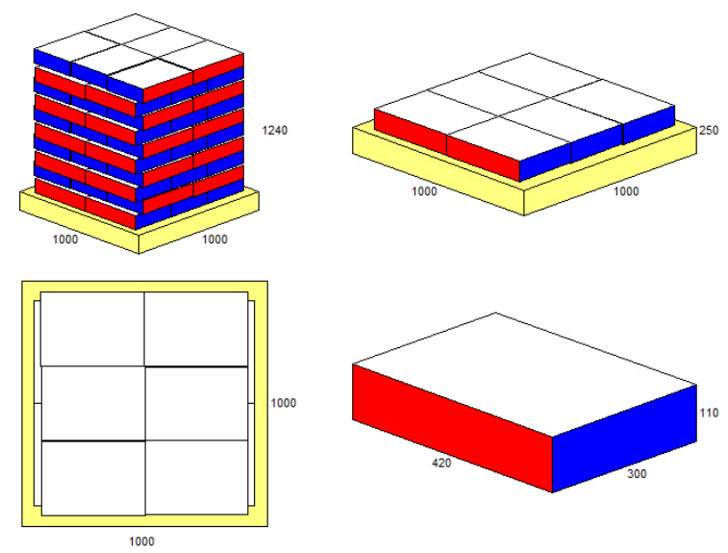
2. Ensure the outer label is attached in the correct placement as requested by the customer. Overlook the quality checks and standards, reject any defects | 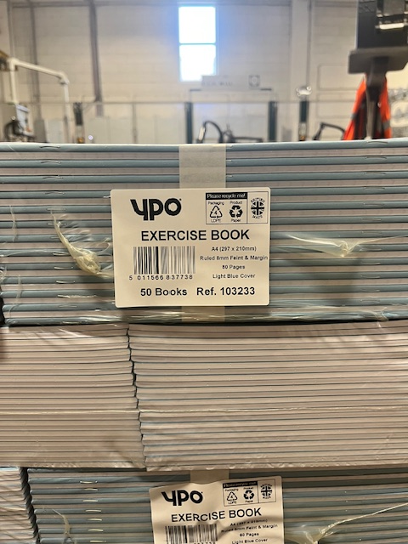
3. Once a full pallet is complete, check the pallet has a finished goods label and send to the relevant department to be stored
4. Keep the work area tidy and fully stocked during downtime periods | 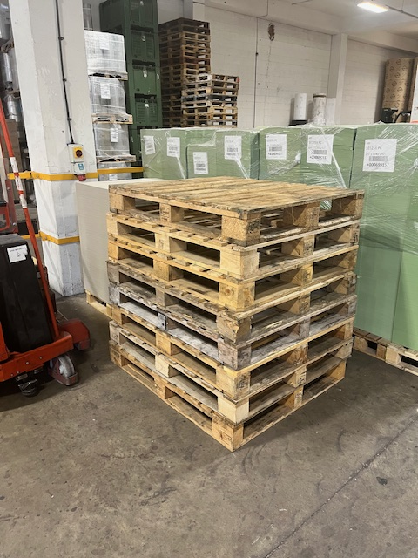

Operating the Over Wrapper/Change Reel

What PPE is required? | - Steel toe cap footwear  - Hearing Protection
Risk Assessment Ref. | - GEN01  - EX02
Quality Procedure Ref. | - QSD476  - QSD476B  - QSD710  - QSD7102

Pre-Shift Check

1. Using the electric pallet truck , move a finished goods pallet up the ramp and into position | 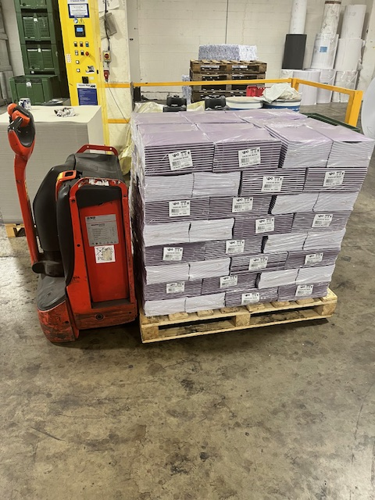
2. Apply a plastic cover sheet to the top of the pallet and tightly tuck the wrap end into the pallet | 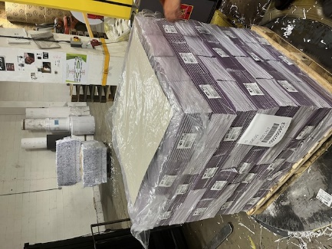
3. On the wrapper control panel, hold down the start button until the pallet begins to rotate, in the beginning ensure to guide the film round the pallet for 2-3 turns | 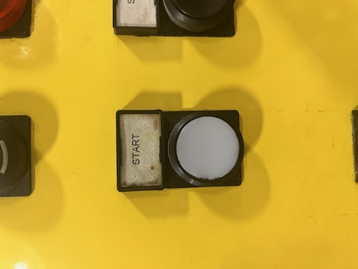
4. Safely insert pallet label whilst rotating. The wrapper will automatically rip and stop on completion. Tuck the trailing end into the pallet | 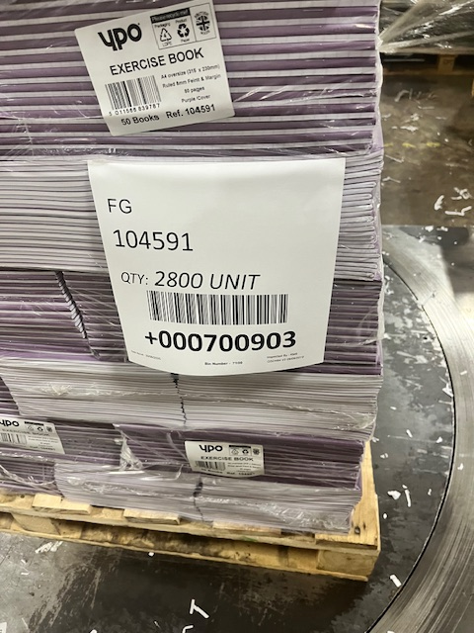
5. Leave the pallet on the wrapper for the forklift drive to safely remove the finished goods pallet
6. To change the reel, remove the old core, place new wrap into holder. Undo guard, rethread the wrap film, shut the guard

Computer Skills

What PPE is required? | - Hearing Protection
Risk Assessment Ref. | - GEN01
Quality Procedure Ref. | - QSD476  - QSD476B  - QSD710  - QSD7102

Pre-Shift Check | Finished goods pallets need to be registered as completed in order to be able to book them out. Each pallet should have an individual pallet number and show in the correct location for picking and stock take needs. Ensure you have the correct login details for traceability and the current works order sheet available.

1. Login to the Emulator account with the correct details | 
2. Navigate to ‘Works Order Receipt’ and input the WO number | 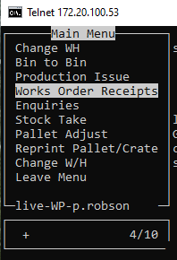
3. Input the pallet quantity, the operators name and how many labels are required. Confirm the location in which the pallet will be put into stock and confirm again
4. For the pack labels, open Bartender and select the correct label required for the current order
5. Check that the label has the correct information (Report to the operator/manager if details are incorrect) and continue to print

Set and Adjust Bander

What PPE is required? | - Hearing Protection  - Steal Toe Capped Shoes
Risk Assessment Ref. | - GEN01
Quality Procedure Ref. | - QSD476  - QSD476B  - QSD710  - QSD7102

Pre-Shift Check

1. When the band has ran out, remove the old reel core and replace with a new band roll
2. Thread the bander
3. Set and adjust to the correct pack size

Sign Off Process Confirmation

Name of Trainee:
Name of Trainer:
Name of Manager:
Start Date:
Completion Date:
Duration Taken to Completion:

 | Trainer Sign/Initial | Trainee Sign/Initial
The Trainee understands the risk assessments involved within this document
The Trainee understands the quality standards required within this document
The Trainee has competently demonstrated the ‘Machine Operation Health & Safety’ to the standard required
The Trainee has competently demonstrated the ‘Prepare Reels’ to the standard required
The Trainee has competently demonstrated the ‘Change Reels’ to the standard required
The Trainee has competently demonstrated the ‘Making a Splice’ to the standard required
The trainee has competently demonstrated the ‘Replace Wire Drum’ to the standard required
The Trainee has competently demonstrated the ‘Change reel on BVM Wrapper/Operate Crane’ to the standard required
The trainee has competently demonstrated the ‘Refeeding the Labeller’ to the standard required
The trainee has competently demonstrated the ‘Pile Down’ to the standard required
The trainee has competently demonstrated the ‘Operating the Over Wrapper/Change Reel’ to the standard required
The trainee has competently demonstrated the ‘Computer Skills’ to the standard required
The trainee has competently demonstrated the ‘Set and Adjust Bander’ to the standard required

 | Name | Signature | Date
Trainee
Trainer
Manager

